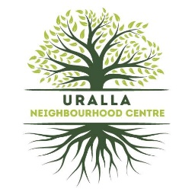
NEIGHBOURHOOD FOOD PANTRY
MEMBER APPLICATION
Membership Number: (To be given by office staff)

First Name: _____________________________________________________
Last Name: ______________________________________________________________
Date of Birth: ____________________________________________________________
Current Address: __________________________________________________________
_________________________________________________________________________
Home Phone: _____________________________________________________________
Mobile: __________________________________________________________________
Email Address: ____________________________________________________________

Centrelink Concession
Type/Number

Do you identify as Aboriginal/Torres Strait Islander? Yes / No
student? Yes / No

Number of dependants (under 18 living with you) __________________________________

Can you please tell us where you found out about food pantry?
___________________________________________________________________________

I consent to the information relevant to support that I receive, being made available as follows and included in the Uralla Neighbourhood Centre’s Data Exchange and any other assistance on my behalf as required.
I, ______________________________ AS A MEMBER OF URALLA FOOD PANTRY AGREE TO GIVE FUNDS TO REPLENISH GOODS RECEIVED.
SIGNED: ___________________________________ DATE:_______________________

2 standard bags: 1 filled with grocery items and 1 filled with fresh food : $30
4 standard bags: 3 filled with grocery items and 1 filled with fresh food : $50
Cost of replacement bags : $1

